Data and Artificial Intelligence

Cyber Shujaa Program

Week 1 Assignment
Web Scraping and Data Handling in Python

Student Name: Rodney Roy Gitonga
Student ID: CS-DA03-26025

Introduction
This week’s assignment focused on extracting structured data from a live website using web scraping techniques. The specific objective was to automate the collection of hockey team performance data from scrapethissite.com.
The objectives of the assignment were:
- Perform practical Python coding on Jupyter Notebooks hosted on Google Colab.
- Use the requests and beautifulSoup libraries to extract data from the web page
- Parse and clean the extracted data for analysis
- Store the structured data into a Pandas DataFrame.
- Export the final dataset to a .csv file.

Tasks Completed
Step 1: Environment Setup and HTTP Request
Began by importing the libraries, requests for handling the connection, beautifulsoup for parsing HTML and pandas for data manipulation. I then defined the target URL and sent a GET request to the server.
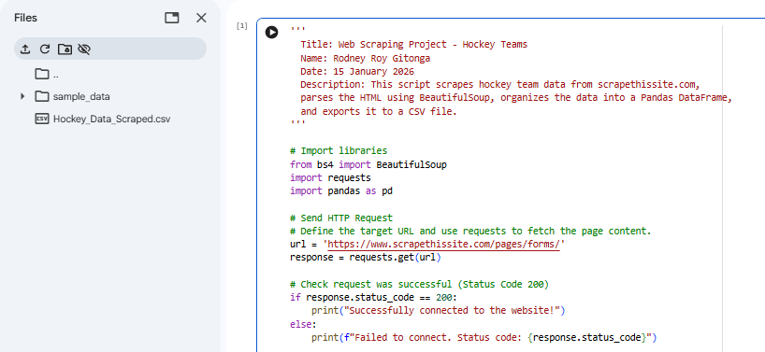
Step 2: Parsing HTML Content
Once connection was established, I used beautifulsoup to parse the raw HTML text. This allowed me to navigate the structure of the page programmatically.
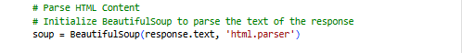

Step 3: Data Extraction and Cleaning
I identified the table headers to create column names then looped through the table rows(tr) extracting the data cells(td) stripping away whitespace and appending the clean data to a list ensuring operation efficiency.
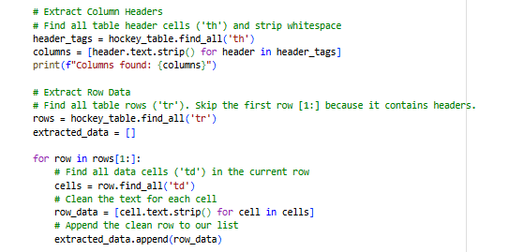

Step 4: Storing Data in a DataFrame
I converted the list of extracted data into Pandas DataFrame organising the data into a clear row and column format.
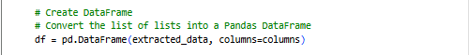

Step 5: Exporting to CSV
I finally exported the DataFrame to a CSV file named Hockey_Data_Scraped.csv to complete data handling cycle.
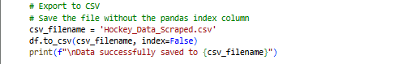

Link to Code:
https://colab.research.google.com/drive/1L6UXoipO2Ac0vGjnx_r9ylQip6E54qf5?usp=sharing

Conclusion
This week I gained a good grounding on the introductory concepts relating to data science and automated data gathering. By successfully scraping the hockey data, I demonstrated the ability to turn unstructured web content into a usable dataset. I am getting a better understanding of Python tools that I can build on as we work on more advanced concepts in later weeks. I look forward to adding this project to my portfolio as I continue to develop my skills in Data and AI.

